./

Learning Report – Applied System Development Life Cycle and Software Testing



|  |  |  |  |  |  |
| --- | --- | --- | --- | --- | --- |
| **Ver. Rel. No.** | **Release Date** | **Prepared. By** | **Reviewed By** | **To be approved By** | **Remarks/Revision Details** |
|  |  | Name/PS No | Name/PS No | Module Owner Name | Comments |
| 1 |  | Mohammed Ijaz /99003728 |  |  |  |

Table of Contents

Table of Figures 3

Table of Tables 4

ACTIVITY 1: SYSTEM/ SOFTWARE DEVELOPMENT 4

**INTRODUCTION**……………………………………………………………………………………………………………………………………………………………5

**MY PRODUCT: “Name ”** 5

**SWOT ANALYSIS** 6

**REQUIREMENTS** 7

**DESIGN** 8

HIGH LEVEL DESIGN 8

LOW LEVEL DESIGN 11

**TEST PLANS** 11

**REFERENCES** 12

ACTIVITY 2: AGILE METHODOLOGY 13

**THEME** 13

**EPIC** 13

**USER STORY** 14

**REFERENCES** 15

APPENDIX:

## Table of Figures

Figure 1 CLASS DIAGRAM(HIGH LEVEL) 10

Figure 2 USE CASE DIAGRAM (HIGH LEVEL) 11

Figure 3 ACTIVITY DIAGRAM (HIGH LEVEL) 12

Figure 4 USE CASE DIAGRAM (LOW LEVEL) 12

Figure 5 ACTVITY DIAGRAM (LOW LEVEL) 13

Figure 6 BLOCK DIAGRAM 13

Figure 7 COMPONENT DIAGRAM (HIGH LEVEL) 22

Figure 8 ACTIVITY DIAGRAM (high level) 23

[Figure 9 ACTIVITY DIAGRAM (LOW LEVEL) 24](https://lnttsgroup.sharepoint.com/sites/GEA/Global%20Engineering%20Academy/GEA%20Insights/Genesis/Shared%20Documents/Submission/MYSORE/2009MYSEMB/Foundation/Applied%20SDLC%20with%20Software%20Testing/99002439/FINAL.docx#_Toc52177322)

Figure 10- ACTIVITY DIAGRAM (LOW LEVEL) 24

Figure 11 TEST PLAN 25

Figure 12 GIT 27

Figure 13 GIT ISSUES 28

Figure 14 GIT COMMITS 1 28

Figure 15 GIT COMMIT 2 29

Figure 16 GIT 30

Figure 17 GIT MAKE 31

Figure 18 GIT MAKE 2 31

Figure 19 GIT BUILD 32

Figure 20 GIT CODE QUALITY 32

## Table of Tables

Table 1 AGING 6

Table 2 GRADING COST 6

Table 3 REQUIREMENTS 8

Table 4 HIGH LEVEL TEST PLAN 15

Table 5 LOW LEVEL TEST PLAN 16

Table 6 USER STORIES 17

Table 7 AGING 19

Table 8 GRADING COST 19

Table 9 REQUIREMENTS 21

Table 10 USER STORIES 27

##### **ACTIVITY 1- TIER PRESSURE MONITORING SYSTEM**

INTRODUCTION:

This document explains a typical tire pressure monitoring (TPM) system specifically intended for automotive use. It serves as a reference to design a real-world system based on various Microchip products. A TPM system primarily monitors the internal temperature and pressure of an automobile's tire. There is a variety of system approaches to follow, although this one is a rather comprehensive auto-location system. An auto-location system can dynamically detect the position of a specific sensor, which is useful when tires are rotated. The heart of the TPM system is the Sensor/Transmitter (S/TX) device and it is based on 8-bit microcontroller with dual-cycle 8051 core.

RESEARCH:

Car model chosen: **2020 GMC sierra Denali**

The SP30 Tire Pressure Monitoring (TPM) Sensor represents Infineon’s standard pressure range TPM sensor. The SP30 offers a high level of integration by including a microcontroller, signal conditioning and LF-input stage to meet market demands for flexible, customer specific solutions and overall system cost reduction.

The sensor design is based on Infineon’s proprietary and patented solutions for high reliability measurements in harsh automotive environments. Its predictable and stable quality is proven in high volume applications.

The SP30 measures pressures up to 900kPa, temperature, supply voltage and acceleration (optional), and by integrating these functions with an ASIC in one package, Infineon has developed the ideal product for standard pressure TPM applications.

**Features**

• Integrated Sensors

o Pressure

o Acceleration (optional)

o Temperature

o Voltage

• Integrated Peripherals

o Microcontroller

o On board EEPROM

o GPIOs

o ADC for signal conditioning

o 2x LF Receiver for triggering

• Measurement Ranges

o Pressure Sensor 100 to 450 kPa / 100 to 900kPa

o Temperature Sensor -40 to +125°C

o Supply Voltage Sensor 2.1 to 3.6 V

o Acceleration Sensor -12 to 115 g

MY PRODUCT- ‘Tier pressure Monitoring System (TPMS)’:

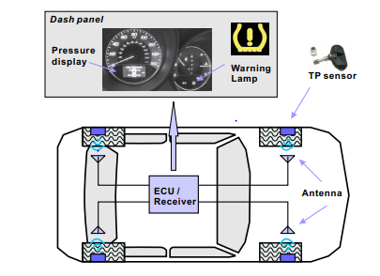

Figure 1: TPMS architecture with four antennas.

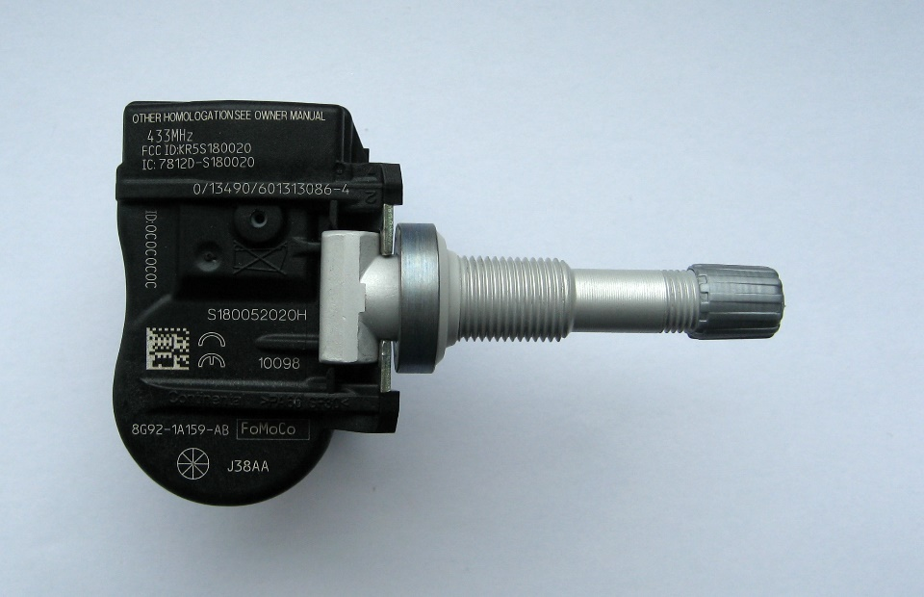

Figure 1.1 TPMS sensor.

There are 2 types of TPMS systems available there days are:

1. Direct TPMS (sensors are mounted into the wheels)
2. Indirect TPMS (measure pressure based on the ABS and wheel sensors information)

We will be looking at Direct TPMS.

Inputs: -

1. Pressure Sensor.
2. Acceleration sensor(optional)

Pressure Sensor: -

1. Tier pressure Monitoring Sensor SP300V5.0E106-0.

* Integrated Sensors
* Pressure
* Acceleration
* Temperature
* Voltage
* Measurement Ranges
* Pressure sensor 100 to 450 kPa (22 psi to 24.1psi)
* Temperature Sensor -40 to +125°C
* Supply Voltage Sensor 2.1 to 3.6 V
* Acceleration Sensor -12 to 115 g (1g=9.8m/s2)
* Absolute maximum Ratings

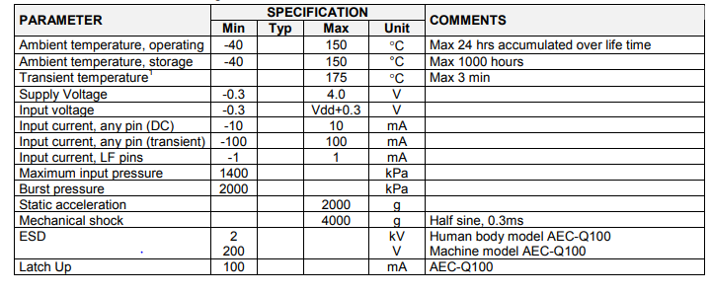

Flowchart:

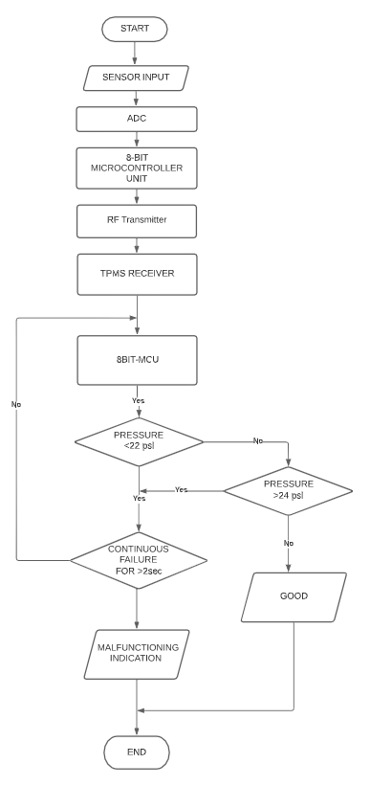

SWOT ANALYSIS:

|  |  |
| --- | --- |
| Strengths   * Direct TPMS contributes 95% of global Tire Pressure Monitoring   System (TPMS) market.   * Various benefits such as Fuel saving, Extended tier life and Improves safety   Are added strengths for TPMS.   * Realtime Continuous monitoring system. | Weakness   * Can be expensive because of the use of costly tools. * Sensors are susceptible to damage during Mounting and demounting. * In case of battery is drained whole sensor needs to be replaced. * Need for resetting: TPMS often have to be reset after a wheel is moved on the car or sensor replaced. |
| Opportunities   * Technological strategies that are used by the key players and forecast growth areas of the global Tire Pressure Monitoring System (TPMS) Market. | Threats |

REQUIREMENTS:

1. OUR PRODUCT FEATURES:

DESIGN:

1. HIGH LEVEL DESIGN:
2. LOW LEVEL DIAGRAM

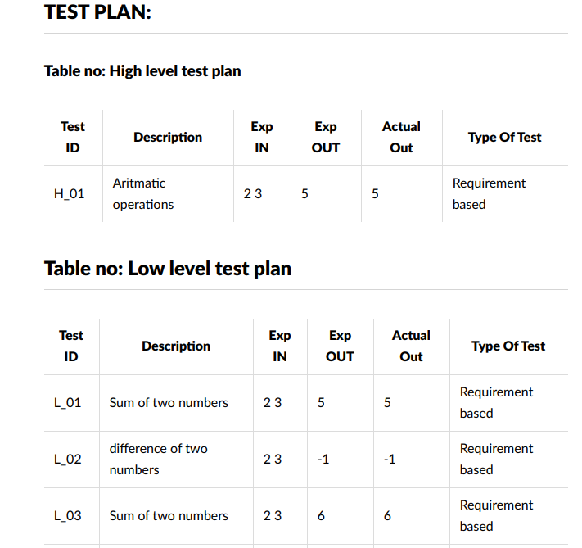

**References-**